**Self-Regulation Thermometer**

**The**

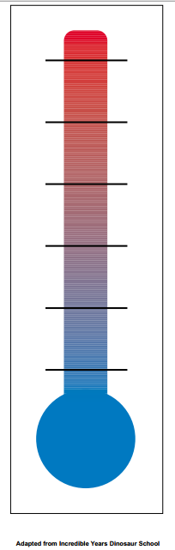

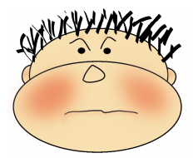

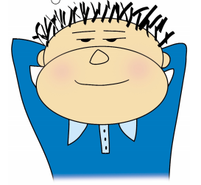

**Mad**

Take 3 deep breaths

1…2…3…

TTtTakeTake

**Relaxed**